Course Code: CSA1557

Course Name: Cloud Computing and Big Data Analytics

R.Pranusha

192111023

7) Create a simple cloud software application for Students Attendance System using any Cloud Service Provider to demonstrate SaaS include the necessary fields such as name of the students, course, present , Absent, course attendance, OD request, grade, attendance percentage, etc.

AIM: To Create a simple cloud software application for Students Attendance System using any Cloud Service Provider to demonstrate SaaS

PROCEDURE:

step1: Go to zoho.com.

step 2: Log into the zoho.com.

step 3: Select one application step.

step4: Enter application name as library book reservation system.

step 5: Created new application as library book reservation system.

step 6: Select one form

step 7: The software has been created.

IMPLEMENTATION:

STEP1: GOTO ZOHO.COM

STEP 2: LOGIN TO THE ZOHO.COM

STEP 3: SELECT ONE APPLICATION

STEP 4: ENTER APPLICATION NAME

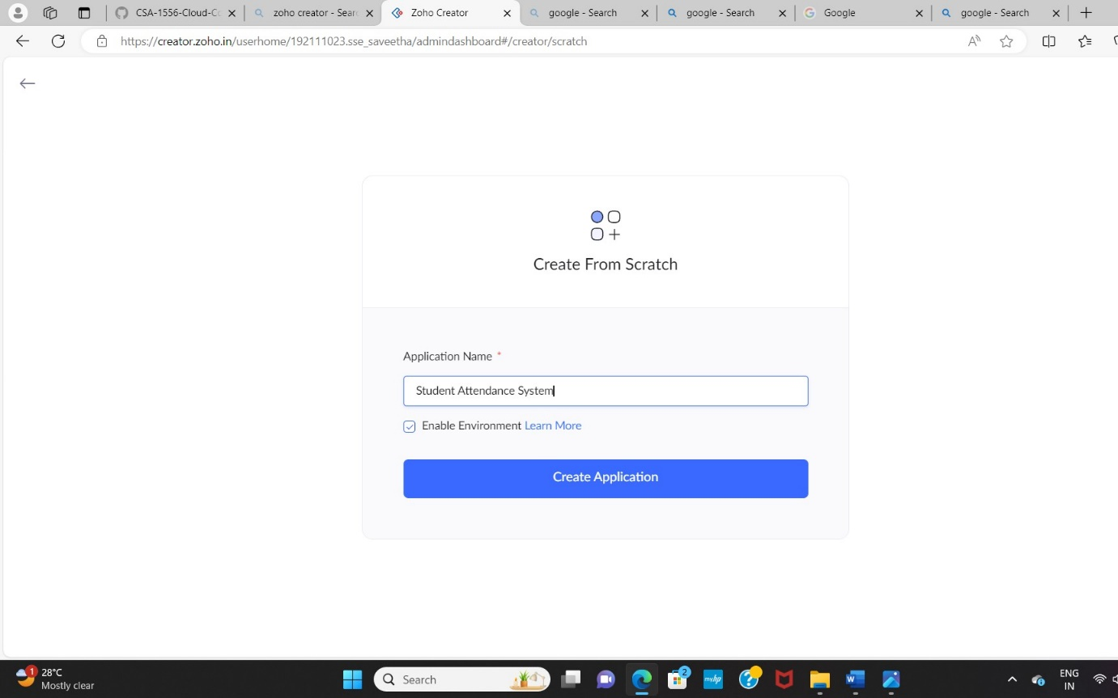

STEP 5: CREATED NEW APPLICATION

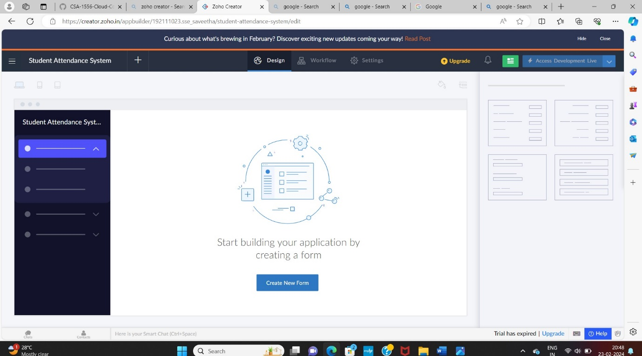

STEP 6: Select from Stratch and Create form as login.

STEP 7: The form has been created as login.

Choose the fields.

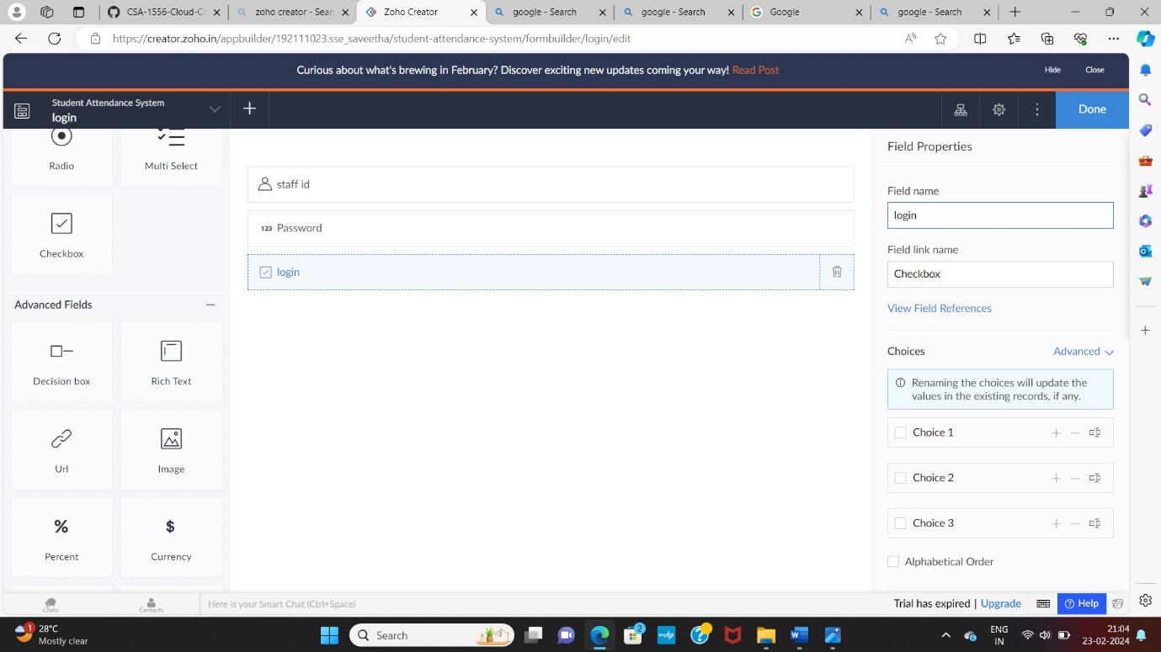

STEP 8: Click Access Development Live and enter the details to access.

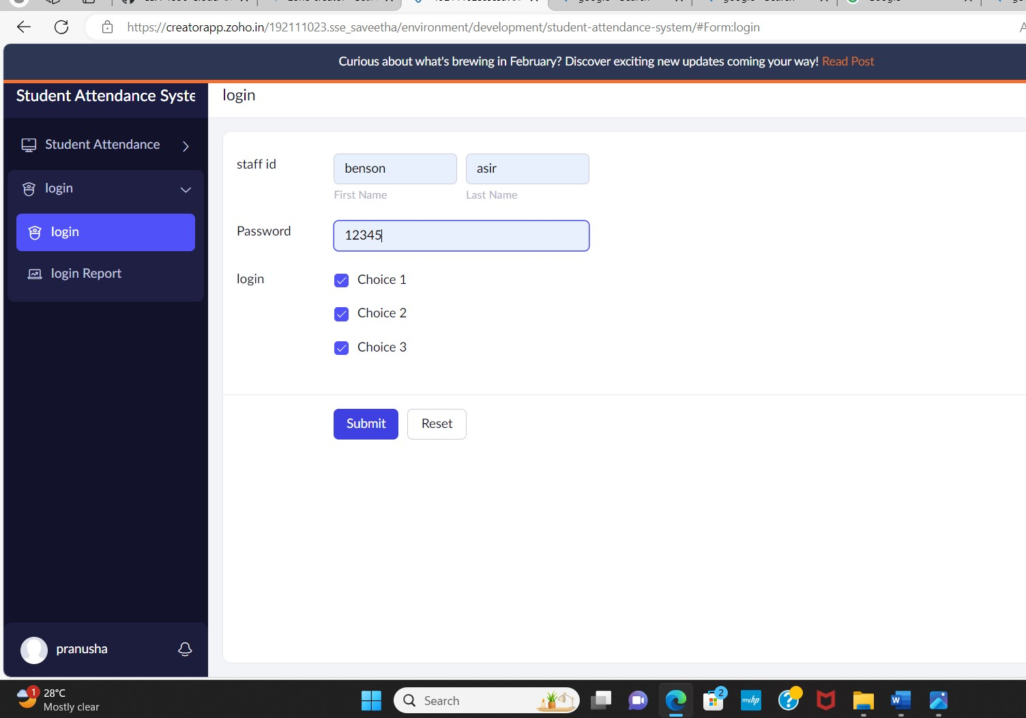

STEP 9: The report has been registered in the login report.

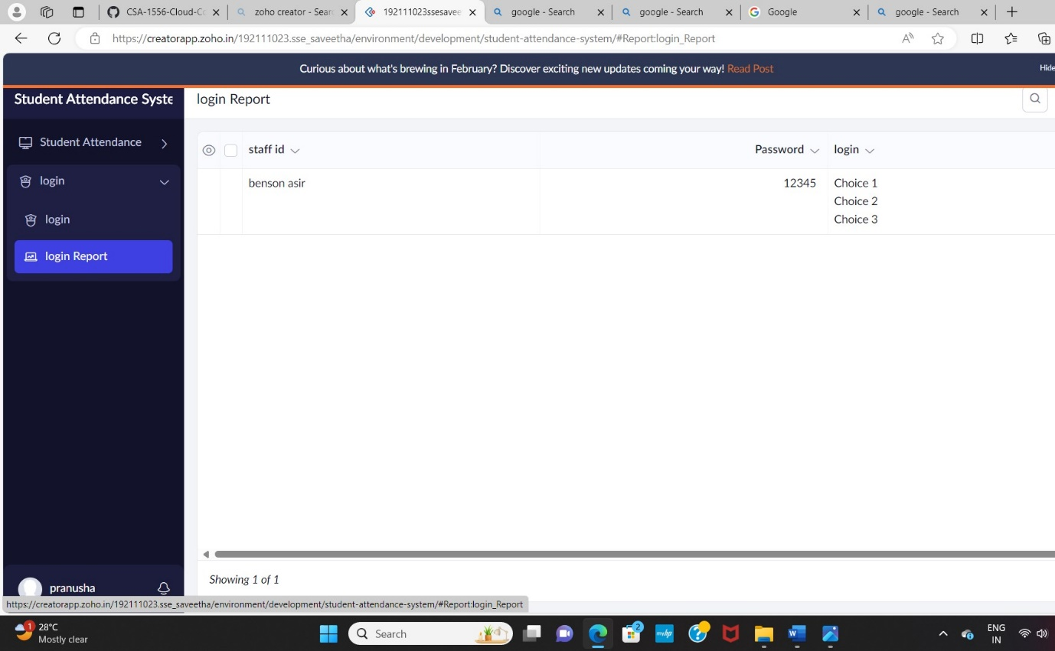

STEP 10: Create a form as Fill Attendance form

STEP 11: The form has been created as Fill Attendance

Choose the fields.

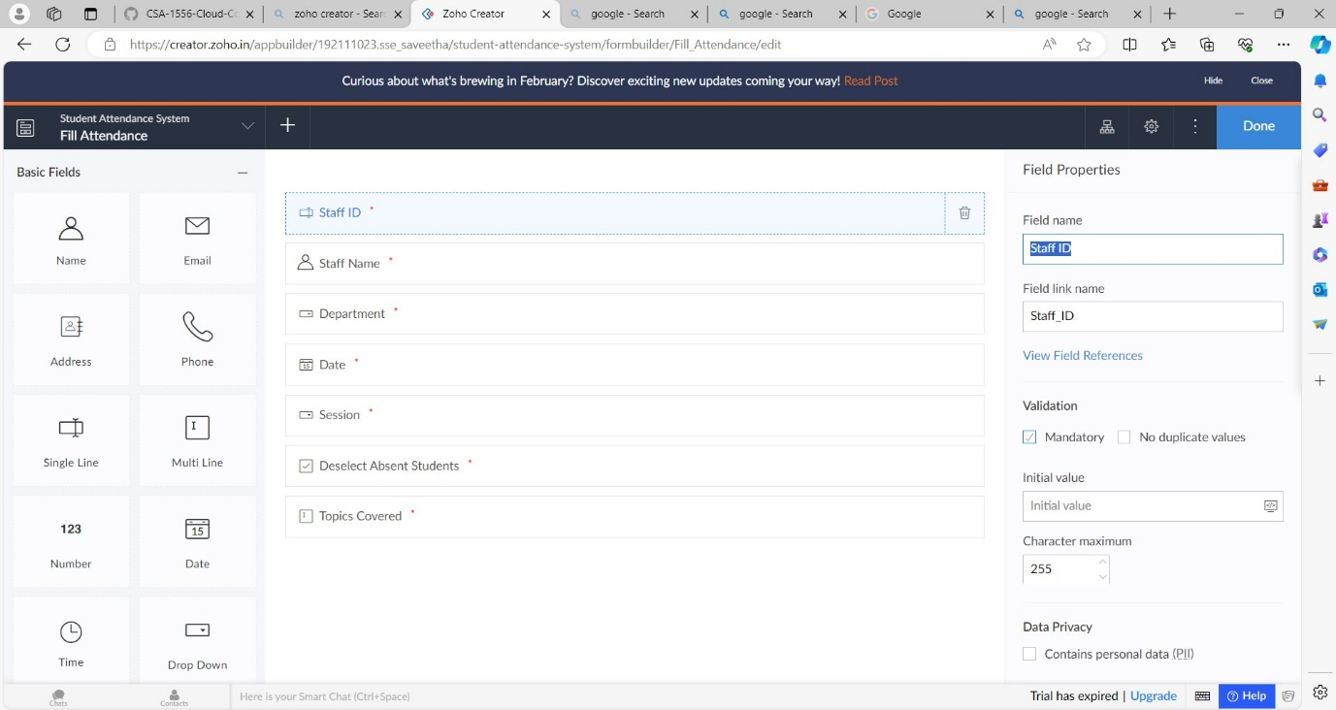

STEP 12: Click Access Development Live

STEP 13: Enter the details of the Attendance.

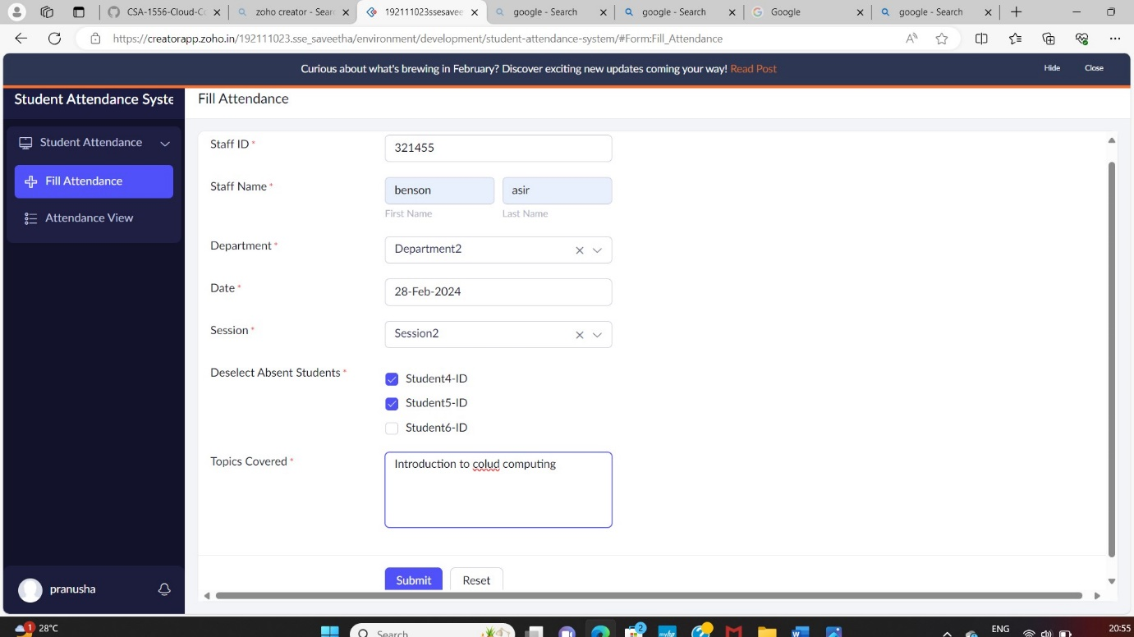

STEP 14: The report has been registered in the Attendance form report.

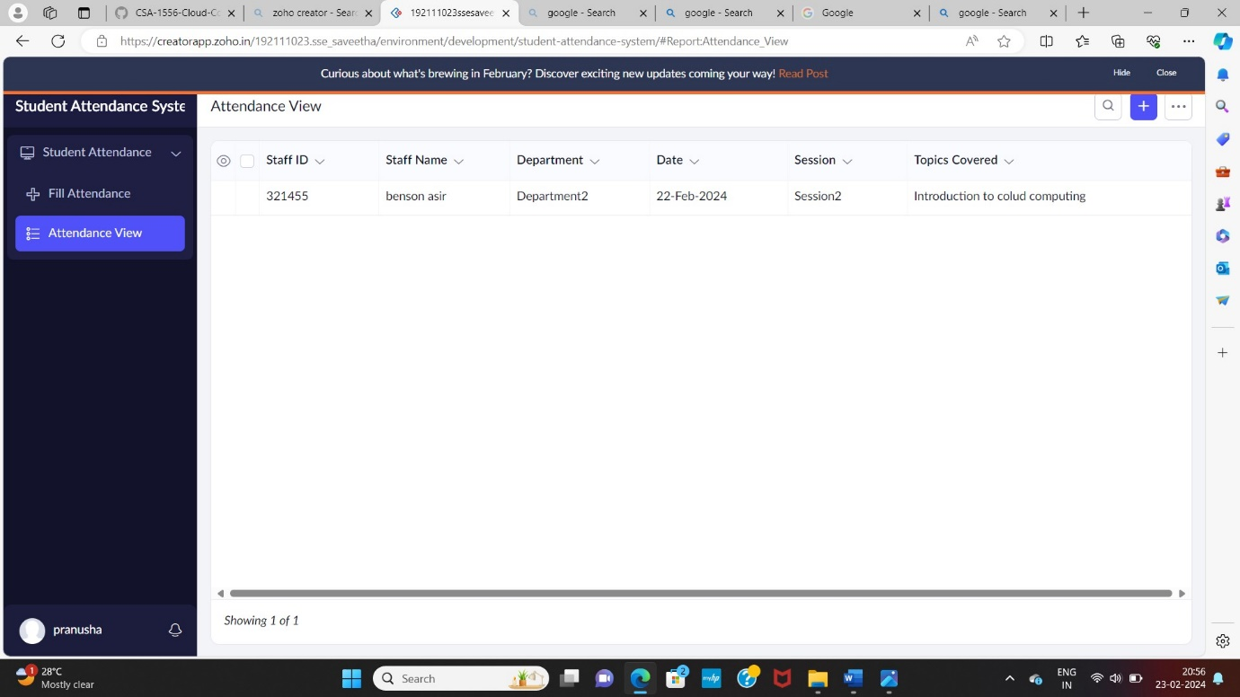

STEP 15: Select from Stratch and Create form as apply leave.

STEP 16: The form has been created as apply leave.

Choose the fields.

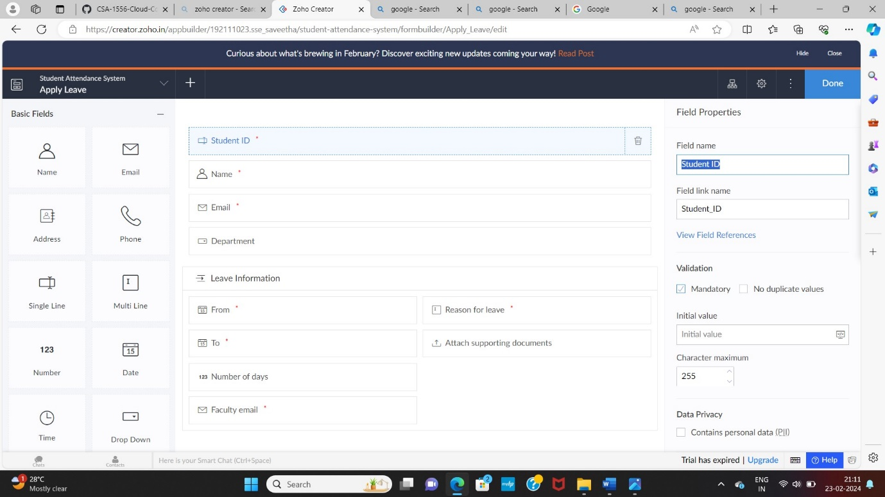

STEP 17: Click Access Development Live

STEP 18: Enter the details of the leave.

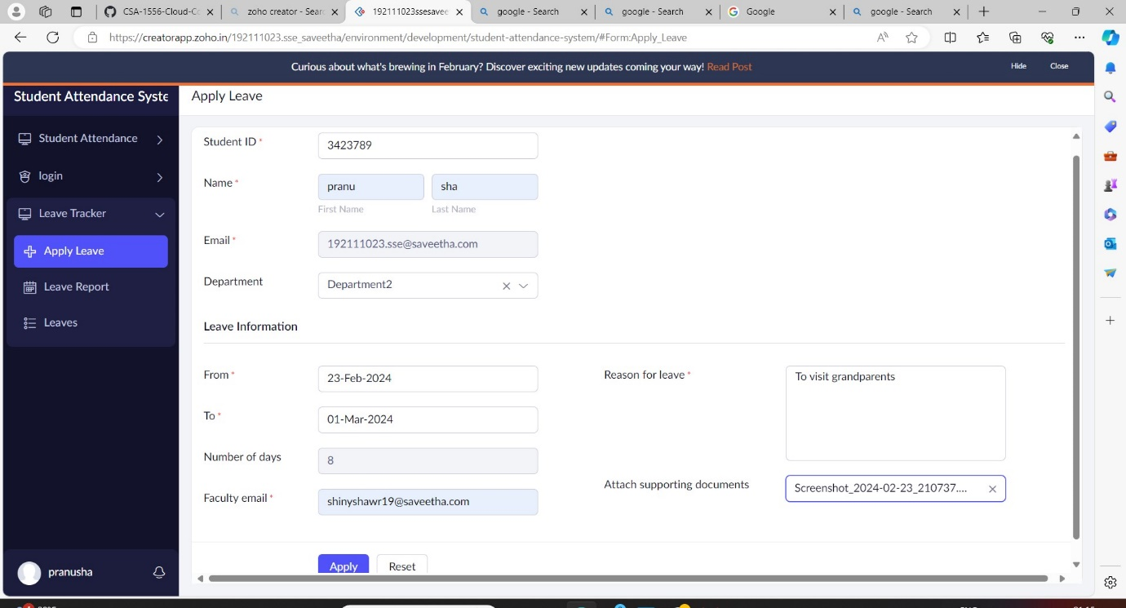

STEP 19: The report has been registered in the apply leave form report.

